**Assignment 11.1:**

Perform and explain the code flow and the associated result for the below tasks. Candidates should

Create and use their own employee dataset for the same. Share the screenshot of the commands used and its associated result.

● Transfer data between Mysql and HDFS (Import and Export) using Sqoop.

* Start all the services: start-all.sh

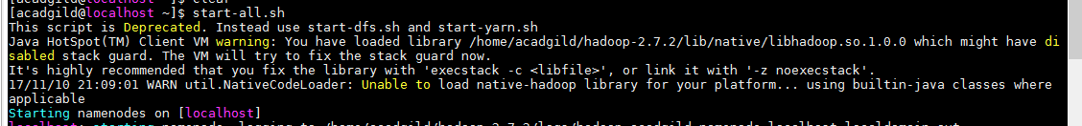

* Start Mysql service  
  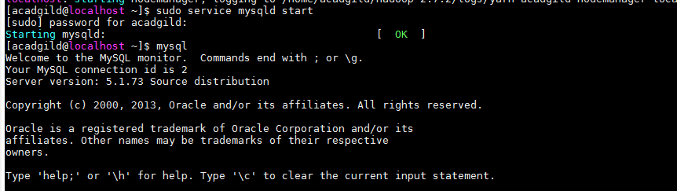
* Create and use database  
  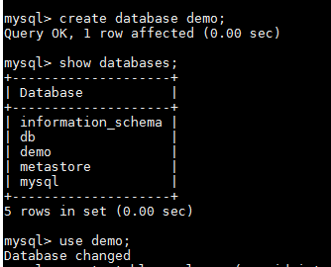
* Create and insert the values into the table  
  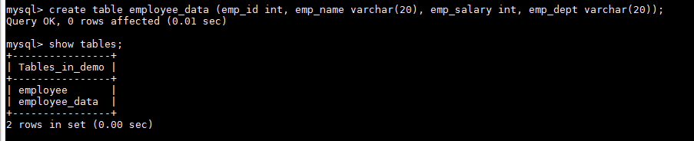  
  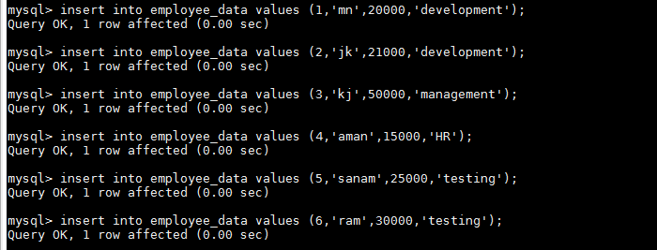
* View the inserted rows in the table  
  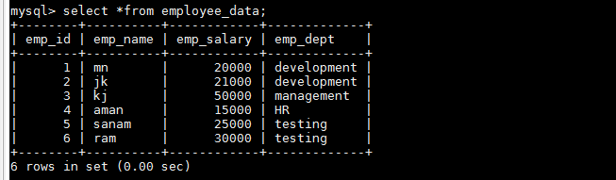
* Give the Sqoop import command by specifying the database name and the table which needs to imported into MySQL  
  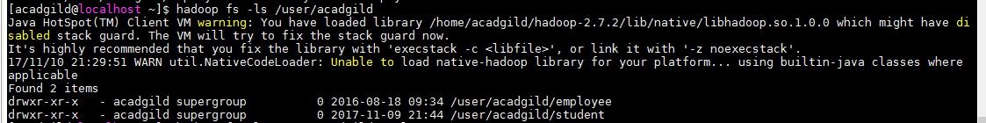

**IMPORT using SQOOP:**  
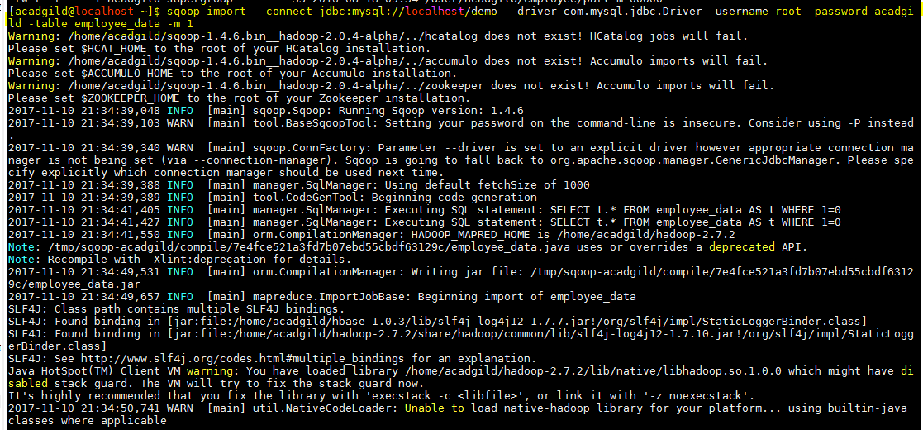  
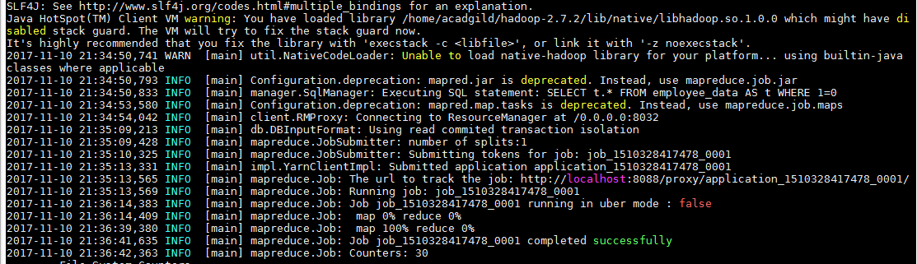

* View the data using –cat which is migrated from the MySQL to HDFS  
  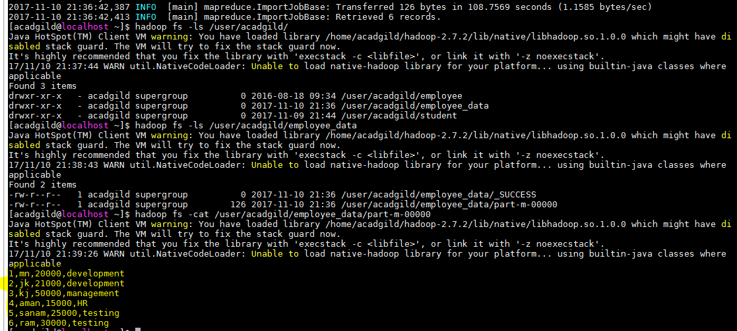
* **EXPORT using scoop:**
* Create a folder in Hadoop/hdfs and put the dataset into that folder.

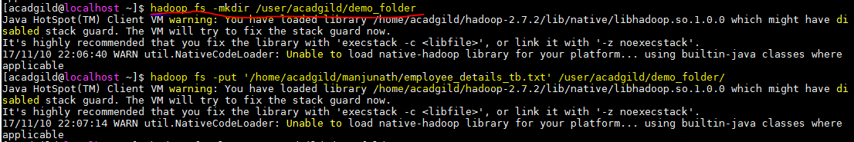

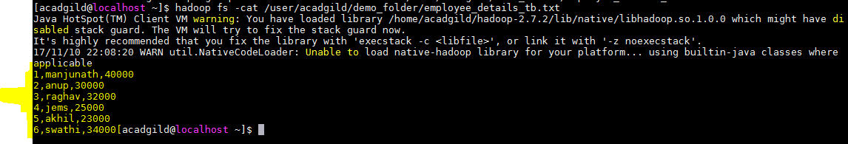

Enter Export command to transfer from the hdfs to MySQL



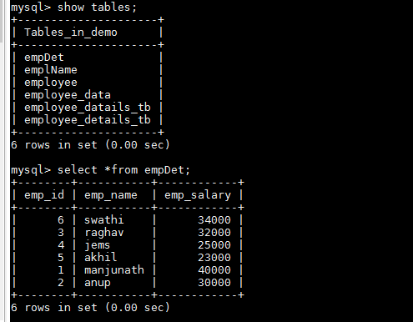

**TASK -2: Transfer data between Mysql and Hive (Import and Export only selected columns) using Sqoop.**

**View the data in Mysql table:**



* Give the below Sqoop command to transfer the data



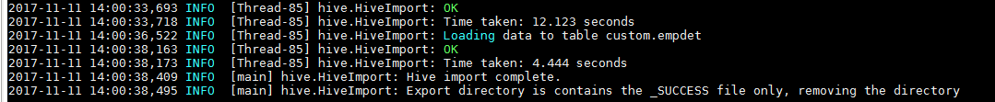

Transfer Data between Hive – MySQL

* Create a table in MySQL which suits the data which needs to be transferred.

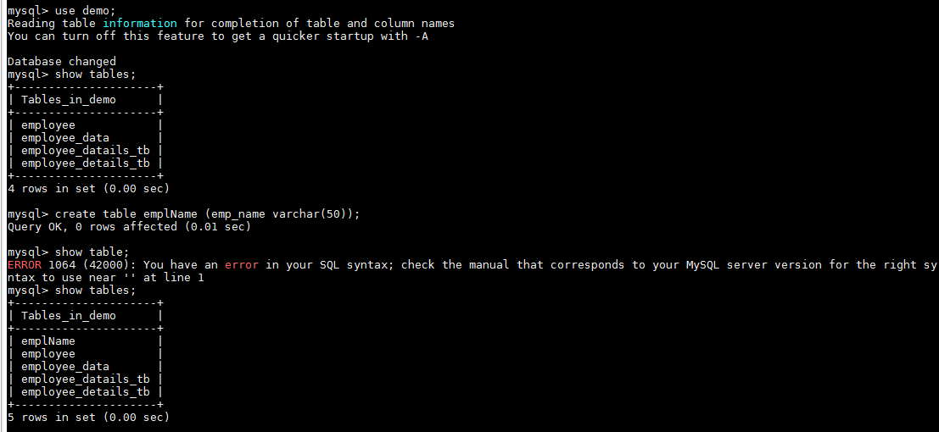

Give Export command as below:



